 | Assignment No. 1  Semester: Fall 2023  CS301 – Data Structures | Total Marks: 20  Due Date: 14th Nov, 2023

Instructions
Please read the following instructions carefully before submitting the assignment solution:
It should be clear that your assignment will not get any credit/marks if:
- Assignment is submitted after due date.
- Submitted assignment does not open or file is corrupt.
- Assignment is copied (From internet/students).

Recommended Tools
- Dev C++

Assignment Submission Instructions
You have to submit only “.cpp” file.
Assignment submitted in any other (zip,.doc, .pdf, image, etc.) format will not be accepted and will be scaled with zero marks. No excuse will be accepted on submitting solution file in any other format.
For any query related to assignment, please contact cs301@vu.edu.pk.

Problem Statement:
You are required to make a program using C++ language to implement singly linked list of random size, populate it with the NUMERIC digits of your VU ID (according to the size that is already generated randomly). And then find the middle node of that linked list, handling both even and odd lengths.

Step By Step Procedure:
- First, you need to decide the size of linked list
  - Generate a random number between 3 to 9 and use it as size of linked list. Every time the program will be executed a different number should be generated.
- Now, create a linked list.
- Fill the linked list while taking input on console, in such a way that user enters the NUMERIC digits of their VU ID, one by one, according to the size generated in STEP 2.
For example, Suppose we got the SIZE from STEP 2 as 5, Now, if we consider dummy vu id ie. BC123456789, then BC would be ignored and you only have to insert 1 2 3 4 5 one by one, in the linked list as we got 5 as the size in STEP 2.
- From the size, you can already tell if your linked list is even or odd, so in case of odd linked list, you can easily find the middle element, like if size is 5, then the 3rd node is the middle one, but if the linked list is of size 6 or any other even number (between 3 -9) then you will get two nodes as its middle nodes i.e. 3 & 4. In that case we will consider the second element as its middle node i.e. 4. (Shown in the graphical representation below)
- As an output, your code should display, the whole linked list and then its middle node. (shown in the screenshot below)
Note: You can implement the above scenario by finding middle index first as shown in the video OR by traversing through pointers.
Important Instructions:
You need to fulfill the following requirements while solving the assignment task.
- Use only user defined classes for Node and List, the use of struct is not allowed.
- The structure of Node and List classes should be similar to the structure given below. If you will create extra data members then your marks will be deducted.
- You need to use your actual VU ID, otherwise marks would be deducted.

Graphical Representation:

Case 1 (Odd Size):
Suppose, a random generated number is 7 and your id is BC123456789

Then your linked list insertion supposed to be:

And in this case your middle node would be Node 4, as show in the figure below:

Case 2 (Even Size):
Suppose, a random generated number is 6 and your id is BC123456789

Then your linked list insertion supposed to be:

And in this case your middle node would be Node 4 according to the instructions given above, as show in the figure below:

Output (ODD):
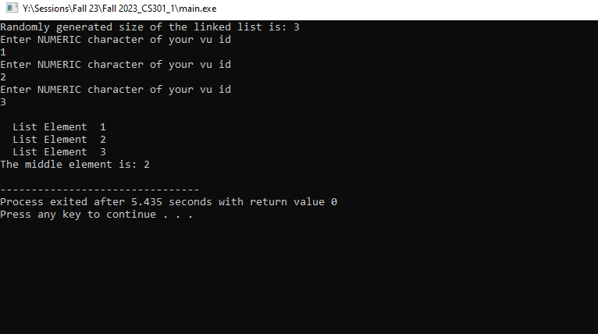
Output (Even):
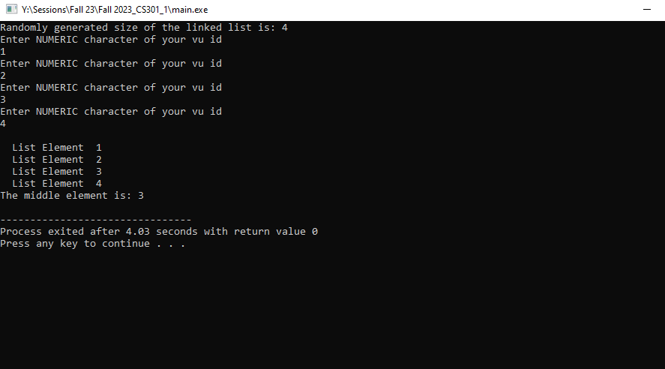

Classes Structure:

Node
-object:int
-nextNode:Node

+set()
+get()
+setNext()
+getNext()

Structure of classes need to be created for required program.
Non Member Functions
main()
friend traverse():void
friend addNodes():List
friend findMiddle():List

List
-headNode:Node
-currentNode:Node
-lastCurrentNode:Node

+List()
+get()
+add()
+next()

Lectures Covered: Lecture # 1 - 10
Due Date:

